

NOVAC TECHNOLOGY SOLUTIONS

User Manual

Document Version No.: 1.00

Revision History
Version No | Reason For Changes | Author | Approver
0.01 | Draft | Ravi
1.00 | Reviewed & Approved the User Manual | Ravi | NIJANTHAN PL

Table of Contents
1. Introduction 4

2. Changes in motor policy schedule 4

Introduction

The document is prepared to understand the reports generated in ZIVA application. This document is being prepared in reference to,
- Guidelines, circulars, instructions and directions released from time to time by Philippines Insurance council.

Functional Overview

System should display the title in grey background color in the Policy schedule output pdf. This is applicable for both Individual Motor and Motor Fleet.

Changes in motor policy shedule

System should display the title with grey background color in the Policy schedule output pdf.

Download motor policy shedule.

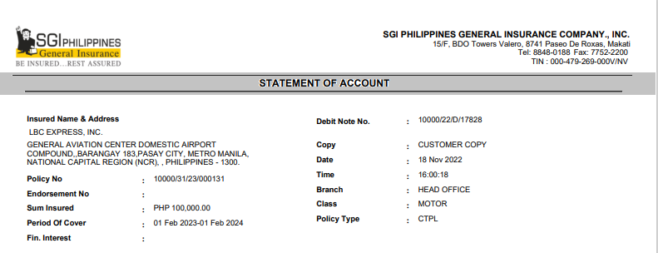

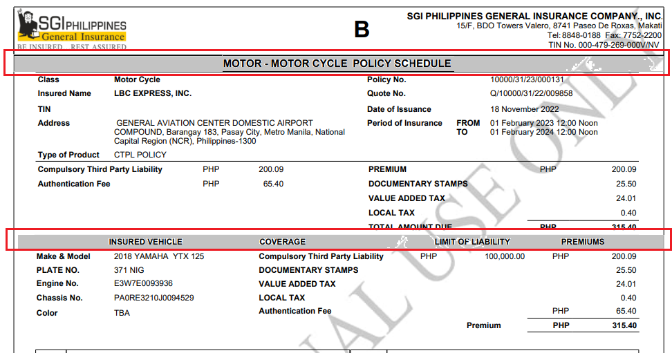

Download motor Fleet policy shedule.

